
Semester | T.E. Semester V – Computer Engineering
Subject | Software Engineering
Subject Professor In-charge | Dr. Sachin Bojewar
Assisting Teachers | Prof. Sneha Annappanavar
Laboratory | M313B

Student Name | Deep Salunkhe
Roll Number | 21102A0014
TE Division | A

Title:
Orthogonal Codes
Explanation:
In coding theory, orthogonal codes play a significant role, especially in communication systems. Two binary codes A and B are considered orthogonal if the inner product of their corresponding sequences is zero.
Mathematically, for binary sequences A=(a1​,a2​,...,an​) and B=(b1​,b2​,...,bn​), the inner product is given by:
A⋅B=∑i=1n​ai​⋅bi​
If A⋅B=0, then the codes A and B are orthogonal.

Bipolar Representation:
Your code uses a bipolar representation of binary sequences, where '1' is represented as 1 and '0' is represented as -1. This bipolar representation is commonly used in communication systems.

Code Implementation:
- Bipolar Function (Bipolar):
  - Converts a binary string to a bipolar sequence.
  - Each '1' is represented as 1, and each '0' is represented as -1.
- Multiply Function (Multiply):
  - Performs element-wise multiplication of two bipolar sequences.
- Main Function:
  - Takes two binary strings as input.
  - Converts them into bipolar sequences.
  - Multiplies the sequences element-wise.
  - Checks if the sum of the multiplied sequence is zero to determine orthogonality.

Implementation:

#include<iostream>
#include<vector>
using namespace std;

void Bipolar(vector<int>&C,string s){
int size=s.length();
for(int i=0;i<size;i++){
if(s[i]=='1'){
C.push_back(1);
}else{
C.push_back(-1);
}
}
}

void Multiply(vector<int>A,vector<int>B,vector<int>&M){
int size=A.size();
for(int i=0;i<size;i++){
M.push_back(A[i]*B[i]);
}
}

int main(){
string A,B;
cout<<"Enter first code"<<endl;
cin>>A;
cout<<"Enter Secont code"<<endl;
cin>>B;
vector<int>AC,BC,M;
Bipolar(AC,A);
Bipolar(BC,B);
Multiply(AC,BC,M);
int temp=0;
int size=A.size();
for(int i=0;i<size;i++){
temp=temp+M[i];
}

if(temp==0){
cout<<"It is Orthogonal"<<endl;

}else
{
cout<<"It is Not Orthogonal"<<endl;
}
return 0;
}

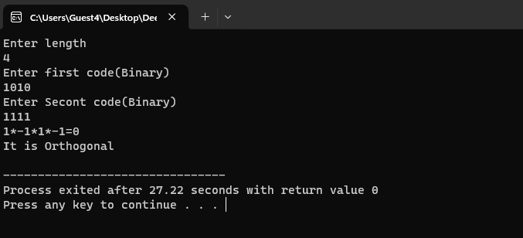
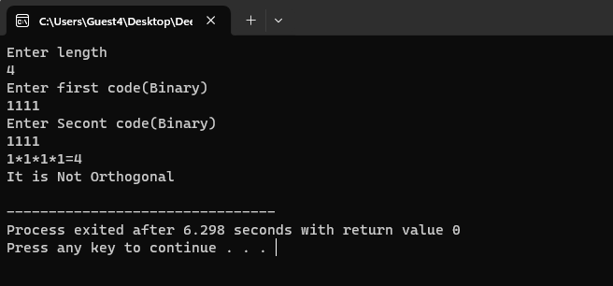

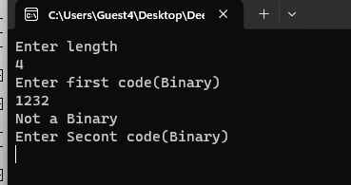
End Result:

Conclusion:

The code essentially checks whether the two input binary codes are orthogonal by converting them to bipolar sequences and performing element-wise multiplication. If the sum of the multiplied sequence is zero, the codes are orthogonal.

